Personal Information
Name: | Gender:
Surname: | Age: - Parent/Guardian  Signature required if under 18.
Parent/Guardian name and Surname: | ID Number
Occupation: | Email:
Contact Details  Mob:  Landline: | Physical address:
Particulars of a friend or family member:
Name:
Contact number:
Important questions:
Have you taken any medication in the last 4 hours? YES NO
Have you taken anything containing Vitamin C in the last hour? YES NO
Have you had an alcoholic beverage within the last 8 hours? YES NO
General Health Information:
Are you currently undergoing any of the following:
Chemotherapy YES NO
Radiation Therapy YES NO
Do you smoke? YES NO
Do you drink alcohol? YES NO
Do you take any illegal drugs? YES NO
Please list all Allergies – (food, medication, chemicals etc)
Please list operations had in the last 6 months – (please specify date)
Client information and Indemnity form

Please circle you fitness level: Poor Good Excellent (Athlete)
Please state your main reason for wanting Ozone or Tripolar Therapy:

Tripolar, Heat/Steam and Ozone Information:
1. Heat applied in a Sauna of any kind can have adverse side effects
a. Cardiovascular problems and some diseases are just two examples of heat sensitive ailments.
2. Ozone does not need extreme heat to be effective, only a moist environment
- All temperatures are regulated by therapists. b. Temperatures in the Ozone Chambers might be increased over time if deemed necessary
3. There are no side effects from ozone except detox reactions which may include a headache
4.Nausea may occur due to liver detox.
5. A course is needed of at least 8.
Rules: (Please tick that you have read the below)
1. If you are actively taking any medication (blood pressure medication, insulin, contraceptive medication, prescribed medication etc) we strongly advise that all medication is taken 4 hours prior and 4 hours after an ozone therapy treatment – Ozone neutralizes chemicals
2. If you are currently receiving Radiation or Chemotherapy treatment we strongly advise that you Wait 4 days after these treatments before having an Ozone Therapy treatment. Please inform you doctor that you are receiving Ozone Therapy.
3. Do not have an alcoholic beverage within 8 hours prior to an Ozone therapy treatment- Increased heart rate and heart size.
4. If you are pregnant we will not under any circumstances administer Ozone Therapy. If you are not 100% sure about your pregnancy status we will not administer Ozone Therapy. – increases babies heart rate
5. Do not take anything containing Vitamin C for 1 hour before or 1 hour after an Ozone Therapy session – Vitamin C destroys ozone

Do you have/suffer from any one of the following:
(No ozone therapy allowed if yes to any of the below)
Acute Alcohol Intoxication: Yes No | Platelet Disorder (Hemophilia) Yes No
Recent heart attack/Stroke (within 3 months)  Yes No | Pregnant Yes No
Active bleeding from ANY site  (internal or external) Yes No | Thrombocytopenia (Thrombosis) Yes No

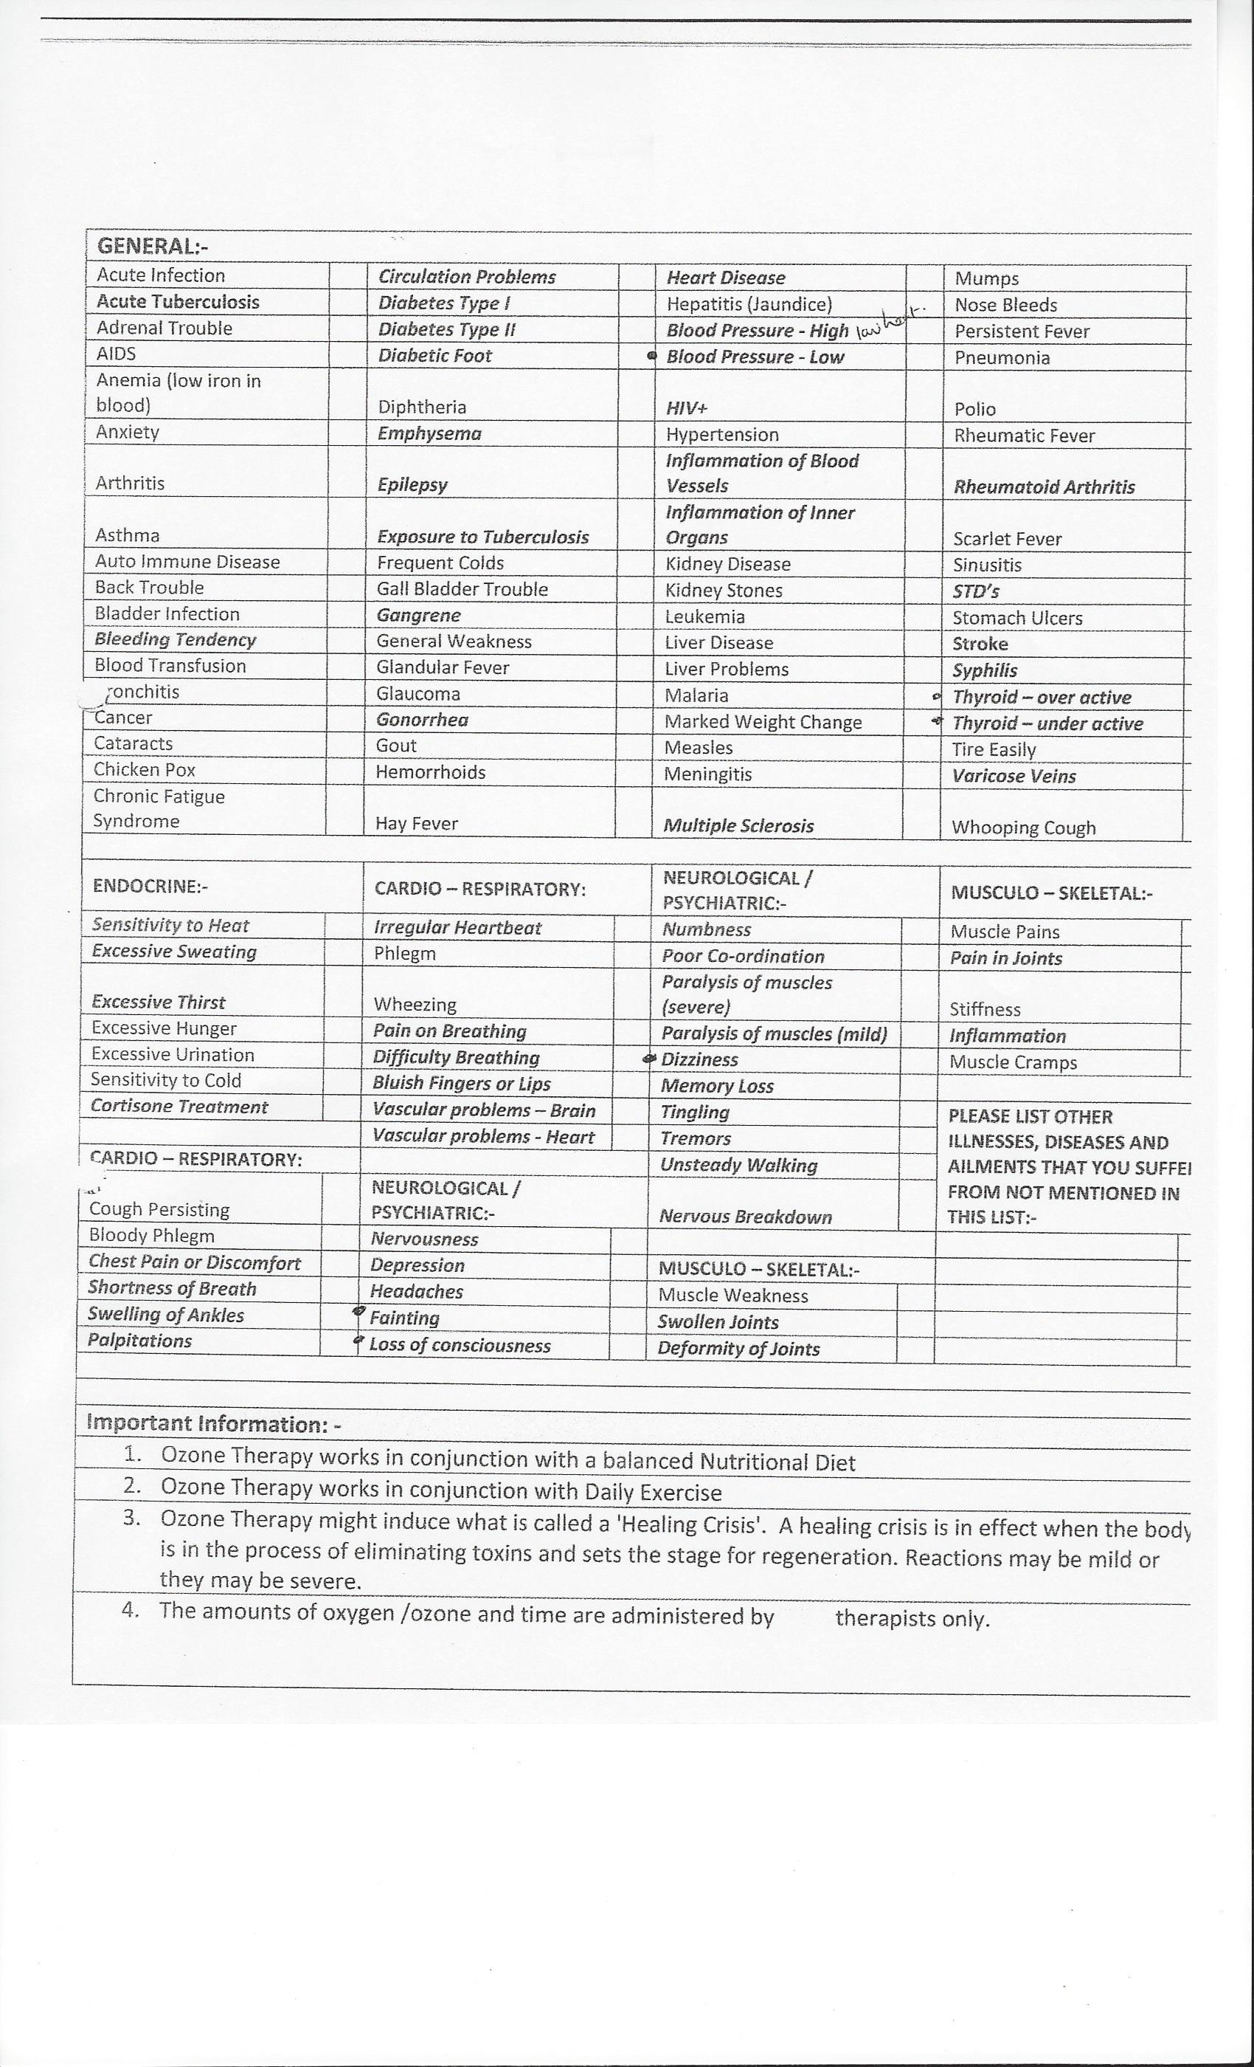
Declaration:
Global Health Clinics cannot and will not diagnose or prescribe medication
Global Health Clinics insists that all customers having Ozone Therapy continue to see a Medical Doctor at all times.
Under no circumstances will Ozone Therapy replace medication/therapies prescribed by a Medical Doctor.
Ozone therapy is to be used in conjunction with Medical science and will under no circumstances replace it.
Global Health Clinics does not In any way guarantee a cure for any ailment or disease.
We offer a detoxification treatment of the human body through Ozone Trans dermal Therapy
There are no health claims being made in the area of scientific validity. There is no claim being made as to the superiority of these methods over any other methods
Indemnity:
1. I Have chosen to attend Ozone Therapy treatments at Global Health Clinics under no duress, and agree to be treated under their supervision.
2. I have made myself familiar with the Rules, Important Information and Declaration outlined and agree
3. I understand that no monies paid will be refunded (or part thereof) for any reason whatsoever, regardless of whether the course has been completed or if satisfactory results have been achieved or not. Furthermore any outstanding monies will still be for the account of the applicant’s details above or his/her guardian.
4. I understand that Global Health Clinics does not guarantee satisfactory or successful results of any kind for all people.
5. Myself my spouse, my children or any other dependant or representative, will claim nothing in case of any loss or damage, resulting from any bodily injuries, loss of life or loss of or damage to property, caused by or arising out of, or which is in any way connected with our voluntary participation in activities at Global Health Clinics or any person in their employ.
6. I agree that I have completed the above form and health questionnaire truthfully and honestly.
I, the above mentioned and undersigned person do hereby understand, acknowledge and agree to all of the abovementioned:
____________________________
Signature of Customer/Guardian
dd/mm/yyyy Date:

